Energy Efficient Resource Allocation in Wireless
Energy Harvesting Sensor Networks
Prof. Name¹, Student Name²
¹Assistant Professor University/College Place
²Student Qualification University/College Place

Abstract – Making the senor to live longer is a significant obstacles to the broad adoption of Wireless Sensor Networks (WSNs). Energy Harvesting (EH) sensors are implemented as a remedy for the aforementioned issue. Their usable lives could be increased by finding the energy they require from their surroundings in a number of different ways. We take into account a Wireless Energy Harvesting Sensor Network (WEHSN) based on TDMA where the time slot consists of two time intervals, the first of which is utilized for sensor data transmission and the second of which is utilized for energy absorption. We analyze the effective resource allocation in WEHSN, in which energy harvest sensor be permitted for broadcasting their output stream if the quantity of energy it has gained exceeds the amount of power it has consumed, under consideration of things such as, planning of timer and TX power usage. The closed form equation of energy efficiency modification issue is created using Dinkelbach method, and it is then converted into a parametric form. The new problem is then solved using Karush-Kuhn-Tucker (KKT) criteria. The analytical solutions show that the suggested strategy is viable.

Key Words: Energy Efficiency, Resource Allocation, Energy Harvesting, Wireless Sensor Networks.

1. Introduction

The rapidly evolving fields of Wireless Sensor Networks (WSN) and Internet of Things (IoT) applications, including the smart home, smart factory, and others, they gained more interest these days. Lifespan of the sensors would be extended and system performance would be greatly enhanced by the efficient use of resources like power and energy harvesting technology.
The usage of a cognitive D2D comm. system for modifying efficiency of spectrum and resource allocation was discussed by Sultana et al. in. Nobar et al. researched a cognitive Wireless Powered Communication Networks (WPCN) consisting a green power beacon, of them secondary network survives with the collection of energy through beacon for power in order to simultaneously give an extended as well as spectrum performance.
In order to derive the closed form equations to the working time for Secondary User (SU) as well as Primary User, authors in this research studied couple of spectrum access techniques of the implementing method, namely a random spectrum access and a spectrum-sensing based spectrum access (PU). Additionally, Nobar et al. have suggested a modified approach to satisfy the demands of resource-limited cognitive WSNs as well as improving of performance of secondary network while adhering to specific QoS restrictions. For PU, they implemented an endless battery status, but they limited the battery life for wireless sensor nodes. Similarly, Yang et al. in [8] attempted for increasing efficiency of energy by decreasing the complete energy spent in a group-based IoT of energy collecting capability, while Ding et al. in [7] examined a repetitive combined allocation of time and managing of resources.
Another strategy proposed in [9] by Pei et al. applies an underlying Non-Orthogonal Multiple Access (NOMA) technique for the network with considering the signal-to-interference-and-noise ratio constraint of the Cellular Users. This joint resource block and transmission power control scheme is for the energy harvesting D2D communications (CU). Additionally, Wu et al. examined [10] how to maximize network throughput in TDMA and NOMA for uplink wireless-powered IoT networks, where the spectral and energy efficiency are restricted to circuit energy consumption.
Another strategy proposed in [9] by Pei et al. applies an underlying Non-Orthogonal Multiple Access (NOMA) scheme to a cellular network under the signal-to-interference-and-noise ratio constraint of the Cellular Users. This combinational block of resources and controlling of TX power is in energy gained D2D comm.(CU). In addition, Wu et al. examined [10] how to maximize network rate of packet delivering in TDMA and NOMA from user to BS wireless-powered IoT networks, in which efficiency of energy and spectrum will be restricted for energy dissipation of network.

2. Related Works

[1] J. Huang, C. Xing, and C. Wang, Efficiency of energy be a key component of upcoming comm. systems, and 5G radio access networks have made this a top priority in all of their design efforts. They are costly for using and difficulty in charging again and using an alternate battery of wireless across many situations, like sensors of humans called as medical sensors that are connected through wireless, have prompted the developing a new technique that enables wireless devices to take energy through the network by using radio frequency signals of ambient. SWIPT has become a potent tool for tackling this problem. In this article, we examine the available SWIPT designs and supporting technologies and list the technical difficulties in implementing SWIPT. To highlight the significance of using SWIPT, we first given a brief explanation of the technologies that enable SWIPT and SWIPT-assisted wireless systems before showcasing a brand-new power distribution method that uses SWIPT. In order to inspire and stimulate additional study on SWIPT, we highlight a few potential future research directions.

[2] K. Kang, R. Ye, In the Internet of Things (IoT) network, where a single hybrid access point (H-AP) with a consistent power source connects with a variety of IoT strategies, wireless power transfer is a new technology that is being studied in this research. It is expected that this H-AP operates in full-duplex mode, which sends and accepts data from and sends the data to Internet of Things devices at the same time for the duration of the entire frame. H-received AP's signals can be used to generate energy by the IoT devices. Additionally, the uplink transmission is supported by the energy that was captured. One Internet of Things device continues to collect energy until its own uplink time slot because from user to BS link uses TDMA. Our aim is that the research is for optimizing overall excess energy, described like difference in the energy available as well as the energy consumed in user to BS links, by employing best time division technique for all devices. Dispersed non-cooperative and negotiating cooperative game-based procedures will be created for addressing the current issue. Additionally, a benchmark is created using the well-known KKT condition technique. Implementation solutions suggests negotiating supportive procedure outclasses the distributed non-cooperative algorithm (DNCA) and the KKT procedure regarding the entire excess energy as well as equality table (KKTA). KKTA outperforms DNCA regarding excess energy, although KKTA will be more equitable compared to DNCA.

[3] Z. Chu, F. Zhou, Z. Zhu, R. Q. Hu, and P. Xiao, In this research, a wireless power-driven sensor network with many sensor nodes placed to track a specific external environment is investigated. These sensor nodes are fueled by a multi-antenna power station (PS) during the wireless energy transmission stage, during the wireless data transmission phase, sensor nodes communicate its personal controlling data to a mixture center using the energy they have collected. Our aim is improving network throughput when both alternative circumstances, such as PS and sensor nodes belonging for the similar or dissimilar facility operators, are taken into account (s). We suggest a total best strategy to simultaneously plan energy beamforming as well as time sharing in the first scenario. In order to respond in closed form to the proposed sum throughput, we continue.

[4] A. Sultana, L. Zhao, and X. Fernando, to improve network performance, a new paradigm called device-to-device (D2D) communication is being developed in accordance with LTE and WiMAX advanced requirements. D2D communication may make use of shared spectrum or dedicated spectrum (overlay) (underlay). While the designated specialized frequency may not be adequately utilized in the overlay mode, interference between cellular users and D2D users degrades the underlay mode. Can the cognitive approach, in which users opportunistically use the radio spectrum that isn't being used as much, be used to optimize the resource allocation of a D2D system? That is the main subject of this essay. This work simultaneously satisfies five sets of power, interference, and data rate constraints while optimizing the transmission rate for D2D users. D2D users are shown as secondary cognitive users..

[5] S. K. Nobar, K. A. Mehr, and J. M. Niya, In this letter, we'll examine an RF-powered green cognitive radio network (RF-GCRN), where a power beacon (PB) serves as the hub and collects green energy from local sources before wirelessly distributing it to cognitive users. Random in-band energy TX by PB serves as a single basis of energy for cognitive users. The effectiveness of this network is tested for both random access and spectrum sensing-based access strategies with just one set of secondary users. The results show that the RF-GCRN paradigm is viable if the energy transmission rate is below a particular threshold. This threshold is determined by the requirements of the spectrum access technique and the maximum delay that the primary user will endure.

3. Implementation

We look at a WEHSN that has one hybrid access point (HAP) and M energy-harvesting sensors coupled to an unlimited power source (see Fig. 1). As indicated in [11], the "harvest-and-then-transmit" technique is applied. In order to communicate data to a wireless information transmission, sensors must first gather energy in a downlink (DL) from a wireless energy transferring (WET) (WIT). The term "Tmax" refers to the longest period of time that can be used to transmit data and collect energy. We take into consideration a WEHSN with TDMA that gathers energy from every sensor.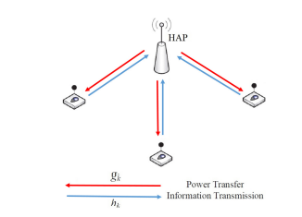

information is transmitted throughout UL WIT and DL WET. The second interval has M slots, one for each sensor. It is assumed that each sensor has the component in the optimal state for a channel information system (CSI) for resource sharing. DL channel rise amid the HAP and sensor I and UL channel increase amongst sensor I and the HAP are represented through the letters gi and hi, correspondingly. Throughout the BS to user phase, HAP shows the energy signal by a continuous power P0 and in an omnidirectional fashion to all sensors. The quantity of energy collected at sensor I can therefore state as

Here, Pcri is circuit's power usage through the energy gathering period, and I is continuous energy alteration factor of the sensor (0, 1). Each sensor is thought to have positive levels of accumulated energy (fi > 0). The appropriate sensor cannot participate in transmission if fi 0 due to a lack of energy.

Each sensor transmits data in the assigned time slot I throughout user to BS link period thanks to TDMA-based WEHSN. Because of this, the energy consumed by each sensor while the information is being transmitted will be equal to (pi+Pcti)i, where pi is the amount of power given for sensor I in the WIT and Pactiv is the amount of power consumed by the circuit. As a result, the throughput for sensor I that can be reached (normalized by bandwidth) can be expressed as
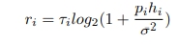

I and 0 are first taken to be constants. Slater's condition [13] is satisfied by the convex optimization problem (8) in this case, which involves pi. The proper application of the Lagrange dual technique enables the rapid discovery of the optimal solution [13]. To do this, we need the answer to the Lagrangian function of issue (8), which is denoted by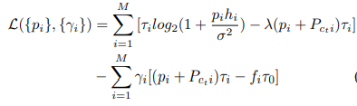
the Lagrangian coefficient, i. Since complementary slackness causes the optimal lagrangian multipliers in constraints C3 to be zero, the corresponding lagrangian multipliers in constraints C3 are not included in equation (9). To comply with Karush Kuhn-(KKT) Tucker's [13] specifications, we have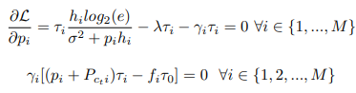

We look at three situations in order to solve (10) and(11).
Case 1) In this case, I = 6 = 0 I = 1, 2,..., 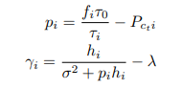
Both pi and I must be bigger than zero in order for KKT to be satisfied (0 pi & 0 I).
Case 2) where γi = 0 ∀i ∈ {1, 2, ..., M}, here we have
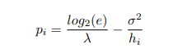
Case 3) To get the pair (0, I), we substitute (12) in the maximizing issue (8). As a result, the problem is modified to each value.
Case 1) To attain the pair (τ0, {τi}), we substitute (12) in maximization problem (8). Thus, the difficult is transformed to
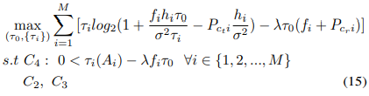
where Ai = (1 − λσ2hi + λPcti) and constraint C4 arises on or after replacing (12) in (13) to fulfil 0 < {γi} restraint C2, C3, C4 are linear, then the object function in (8) can then written likes
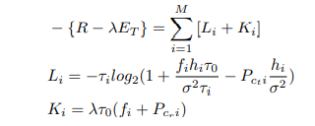

Whereas, 2 (Li) > 0 demonstrates the convexity of Li and suggests that Ki is a linear function according to equation (17).
The maximization problem (15) thus meets both Slater's condition and is a concave optimization problem. The Lagrangian function of issue (15) takes the following form to produce the best solution: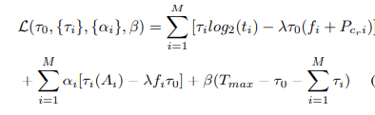
where ti = (1 + fihiτ0 σ2τi – Pcti hi σ2 ) and {αi} and β consist of Lagrangian coefficients. Ti will be positive because Pcti is thought to be quite small. Following are the KKT conditions.
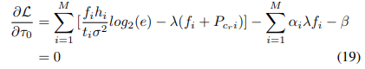
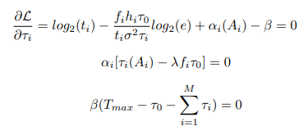
Due to constraint C4 and the fact that I 6= 0, the parameter I is equal to zero (21). By replacing (19) with (20), we get the following equation.
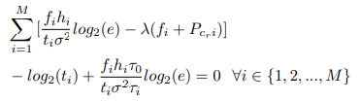
When I = 0 is defined, all is I 1, 2,..., M can be discovered from (23). Additionally, in order to meet (22), we need to have (0 + PM i=1 I =Tmax), so we may deduce 0 and I I 1, 2,..., M as follows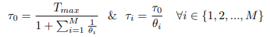
Case 2) We replace (14) in problem to get relevant ('0, I in case two (8). Consequently, the issue mentioned in (8) is changed to
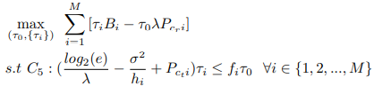
where Bi = (log2(log2(e)hiσ2λ) − log2(e) + σ2λhi− λPcti). An example of a linear optimization issue is the maximum problem in (25) Therefore, it is simple to calculate (0, 1).
Case 3) Problem (8) is changed to Problem (26), a combination of problems, by entering the estimated pi from Case 3 into the problem (15) and (25)
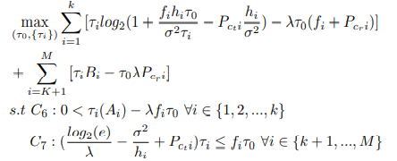
Using the equation, the answer to difficult (26) to obtain 0 then I might remain reached similarly to case (1). (24).

4. Results

After 5000 rounds the number of nodes alive are plotted in the below graph. It can be noted that total number of nodes started to die after some 3500 or more rounds which is the maximum capacity we have achieved with this type of protocol.

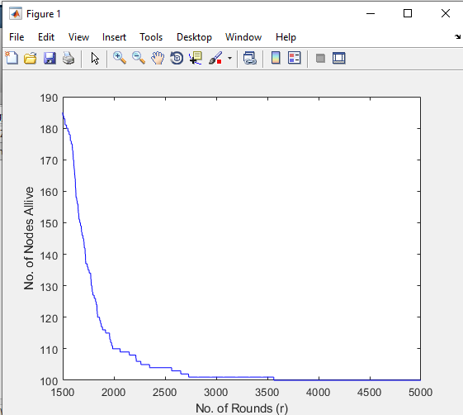
Fig -1: No of Nodes Alive after 5000 Rounds

After 5000 rounds, the consumption of energy of all the nodes in the network are plotted in the below graph. It can be noted that, the energy consumption is stretched to more than 2500 rounds which is possible because of our proposed protocol.

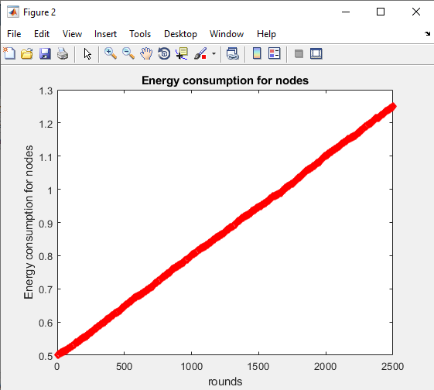
Fig -2: Energy Consumption for Nodes

Energy efficiency vs HAP transmit power are plotted in the below graph, which shows a greater usage of transmit power for making the nodes alive to some longer rounds than typical limit. It shows that, the current protocol can maximize the power usage minimal power.

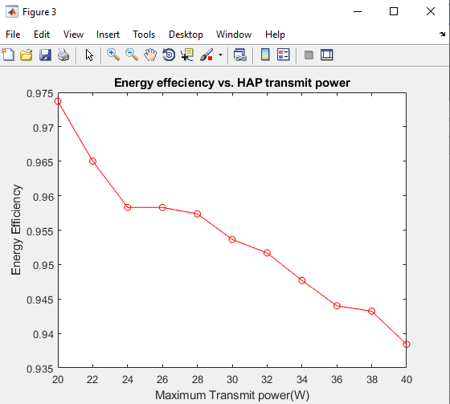

Fig -3: HAP TX power Vs Energy efficiency

Hap TX power Vs throughput are plotted in the below graph which shows the increase of transmit power when the throughput minimizes shows that the proposed protocol maximized the throughput of the network.

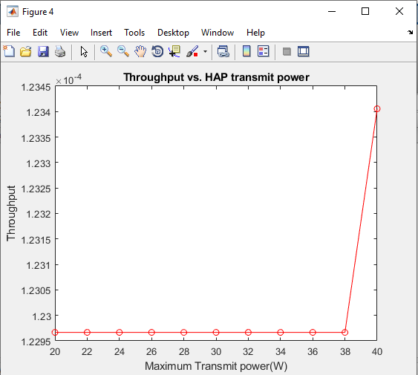

Fig -4: Hap TX power Vs throughput

5. CONCLUSION

In this article, we provide a brand-new system design where wireless sensors gather the energy needed for data transmission, then transmit using the harvest with transmit protocol. Additionally, the sensors interact consisting an access point of hybrid during the remaining time span using TDMA. We get at the energy efficiency optimization problem by putting limits to the time scheduling parametre and TX pow of every sensor to the system performance. Using the Dinkelbach algorithm, the issue is resolved, and expression of form of closed are obtained. The analytical findings demonstrate that throughput could slightly fall in comparison to the other ways, the energy usage would decrease significantly more, leading to maximize of efficiency of network’s energy.

REFERENCES

[1] J. Huang, C. Xing, and C. Wang, “Simultaneous wireless information and power transfer: Technologies, applications, and research challenges,” IEEE Communications Magazine, vol. 55, no. 11, pp. 26–32, Nov 2017.

[2] K. Kang, R. Ye, Z. Pan, J. Liu, and S. Shimamoto, “Full-duplex wireless powered iot networks,” IEEE Access, vol. 6, pp. 53 546–53 556, 2018.

[3] Z. Chu, F. Zhou, Z. Zhu, R. Q. Hu, and P. Xiao, “Wireless powered sensor networks for internet of things: Maximum throughput and optimal power allocation,” IEEE Internet of Things Journal, vol. 5, no. 1, pp. 310–321, Feb 2018.

[4] A. Sultana, L. Zhao, and X. Fernando, “Efficient resource allocation in device-to-device communication using cognitive radio technology,” IEEE Transactions on Vehicular Technology, vol. 66, no. 11, pp. 10 024– 10 034, Nov 2017.

[5] S. K. Nobar, K. A. Mehr, and J. M. Niya, “Rf-powered green cognitive radio networks: Architecture and performance analysis,” IEEE Communications Letters, vol. 20, no. 2, pp. 296–299, Feb 2016.

[6] S. K. Nobar, K. A. Mehr, J. M. Niya, and B. M. Tazehkand, “Cognitive radio sensor network with green power beacon,” IEEE Sensors Journal, vol. PP, no. 99, pp. 1–1, 2017.

